Certificate of Appreciation
Sons in Retirement, Inc.
Las Trampas Branch 116

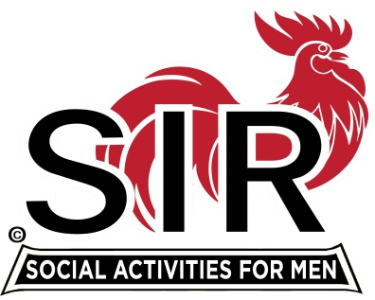

Activities ~ Friendship

To

Bob Shader

You have served our Branch so well for at least the past 15 years as Assistant Treasurer and a contributing member of the Branch Executive Council. You have donated you time and effort all these years to make our Branch better for all.

Jerry Hicks
Jerry Hicks, Big Sir

November 18, 2019

Date

